A Manual for Quantifying Above- and Below-Ground Forest Biomass using R and ArcGIS

Date of Workshop: 4-6 July 2017

Location: GIS Lab, DFRR

Instructor: Eiji Matsuzaki

Table of Contents

1 Background 1

2 Objective 1

3 Expected deliverables 1

4 Biomass Calculation using R and ArcGIS 1

5 Structure 2

6 Applications & Dataset 2

6.1 Application 2

6.2 Dataset 3

7 Practices 3

Step 1: Data Preparation 3

7.1 Create Working Folder 3

7.2 Export GIS Database to .dbf file 3

7.3 Copy and Paste NFI Inventory & GIS Datasets 4

Step 2: Estimation of AGB/BGB 5

7.4 Open RStudio 5

7.5 Run R code 5

7.6 Area of Forest and Woodland 9

7.7 Total Forest Growing Stock 10

7.8 AGB/BGB Biomass 14

7.9 Carbon in AGB/BGB (million tonnes) 14

7.10 Export Output Table 14

Appendix 1

1 A list of R packages and functions used for estimating AGB/BGB during the workshop 1

2 Three Scenarios for Estimating AGB/BGB 2

2.1 Which scenario to use? 2

3 How to Bridge R and ArcGIS 3

3.1 Install R-ArcGIS Bridge 3

3.2 Scenario 1: Raw Code 9

3.3 Scenario 2 14

3.4 Scenario 3 18

3.5 Construct ModelBuilder in ArcGIS 22

# Background

In the previous workshops, we identified a technical gap in quantifying forest biomass using the entire NFI data accumulated over time. EXCEL is a user-friendly application for data storage but not suited to manipulating and analyzing a large volume of data. Consequently, we need a more sophisticated data-handling application to quantify forest biomass in Botswana.

R is now compatible with ArcMap or ArcGIS Pro being able to read, write, analyze and share spatial data via a recently developed R package called ‘arcgisbinding’. As such, R has caught attention from forest practitioners who handle and analyze forestry data.

# Objective

This technical session aims to introduce and employ R programing language to quantify forest biomass (AGB/BGB) and its carbon contents using the latest forest GIS and NFI datasets. A primary purpose of using R is to reduce uncertainty in forest biomass estimates through the reduction of human errors by automating the biomass calculation steps, and also to reduce operational burdens for data users.

# Expected deliverables

Given that few participants are familiar with R programming, they are expected to:

* familiarize yourself with what R can do in terms of AGB/BGB biomass quantification.
* be able to use this user manual properly for quantifying AGB/BGB biomass.
* demonstrate your understanding of general concept of utilizing R programming (i.e., why are we using R instead of Excel?)

# Biomass Calculation using R and ArcGIS

The following figure portrays a simplified operational flow of AGB/BGB calculation using R and ArcGIS

# Structure

For this workshop, we will be employing the simplest approach for estimating AGB/BGB. An entire work flow in this workshop is illustrated in the Figure below. A major calculation process constitutes two steps: data preparation and estimation of AGB/BGB, which are further broken down into micro-steps described in the operational flow.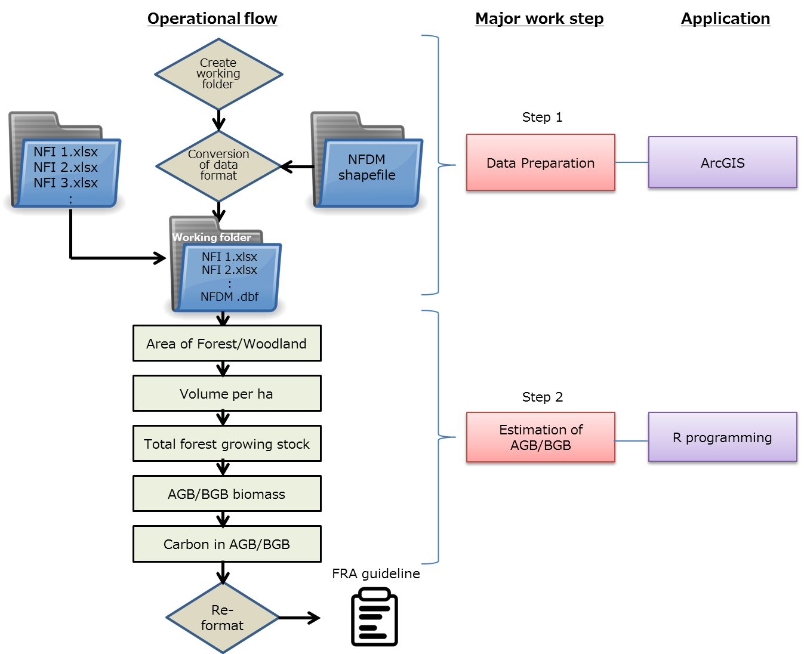

Figure Main operational workflow for estimating AGB/BGB using R programming for Scenario 1

# Applications & Dataset

## Application

|  |  |
| --- | --- |
| Application | Source |
| R | <https://www.r-project.org/> |
| RStudio | <https://www.rstudio.com/> |
| ArcMap |  |

## Dataset

|  |  |  |
| --- | --- | --- |
| Data type | Name | Location |
| File geodatabase | NFDM Final.gdb | /Desktop/treebiomass |
| EXCEL | NFI Inventory.xlsx | /Desktop/treebiomass |
| ArcGIS file | BFDM_v4_20160408_A3_Workshop.mxd | /Desktop/treebiomass |

# Practices

## Step 1: Data Preparation

## Create Working Folder

Create a temporary working folder called **treebiomass** on Desktop where all datasets, R programming codes, and out puts will be stored for biomass calculation.



## Export GIS Database to .dbf file

* Open ArcGIS by double-clicking “BFDM_v4_20160408_A3_Workshop.mxd”

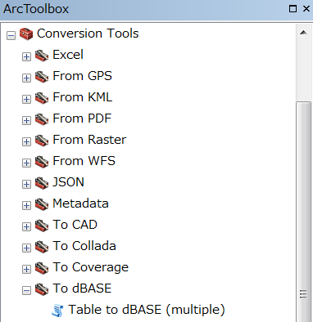

* Open “Table to dBASE” (ArcToolbox -> Conversion Tools -> To dBASE)
* Input Table: Choose “BFDM_Final”
* Output Folder: Choose our working folder “treebiomass”on desktop

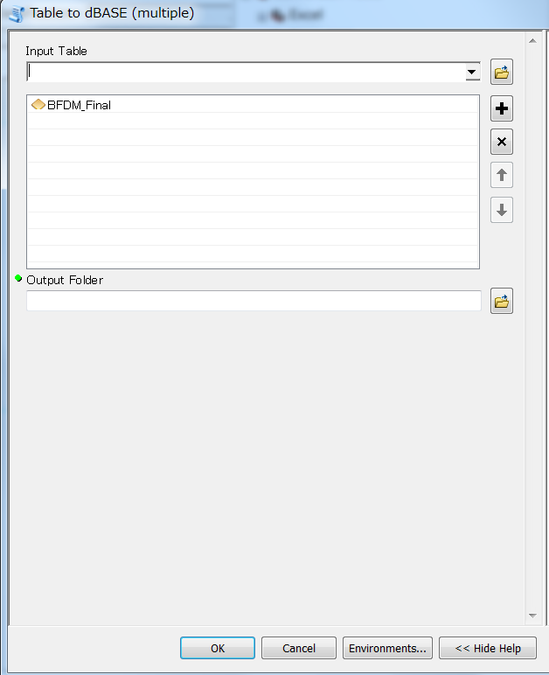

## Copy and Paste NFI Inventory & GIS Datasets

Copy and paste all NFI inventory Excel files into this temporary working folder “treebiomass”

Datasets

NFI 1.xlsx

NFI 2.xlsx

NFI 3.xlsx

:

BFDM_final.dbf



**treebiomass**

**NFI Database**

It is important that you DO NOT work on original files in case something goes wrong. This process is sort of QA/QC measure that can avoid corrupting the files via unintended consequences or irreplaceable human mistakes.

## Step 2: Estimation of AGB/BGB

## Open RStudio

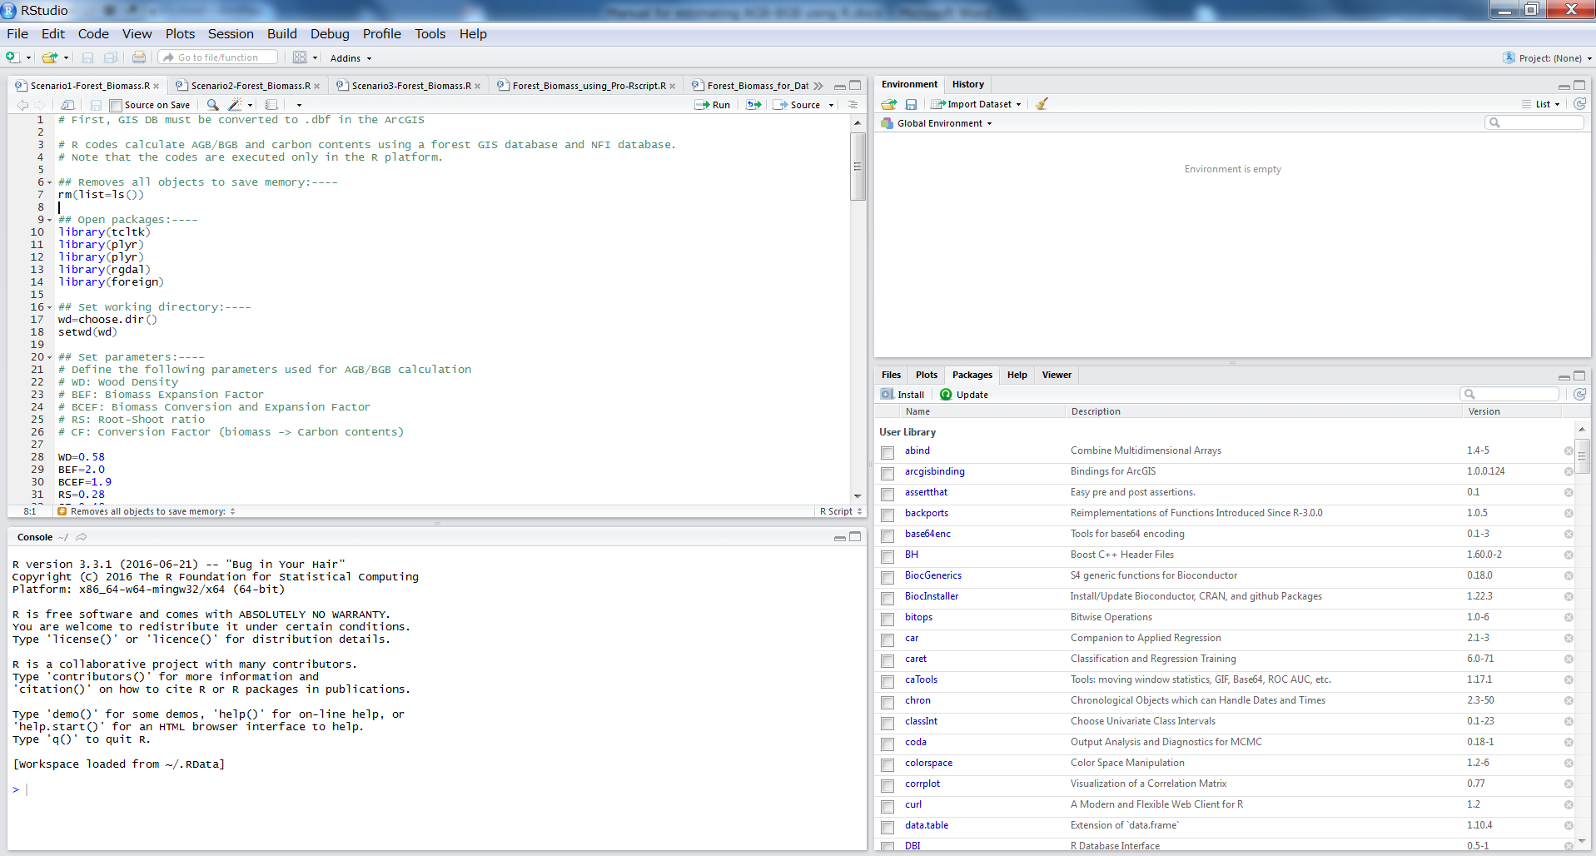

## Run R code

As learning R is not easy, especially for beginners, this section gives you all the R codes necessary for calculating AGB/BGB with minimal instructions. The R codes here are designed in such a way that participants can follow only a few steps for quantifying AGB/BGB. All the R codes are explained in details at the next section (7.5.1) so just run!

* Open R code file
* Click the file icon below

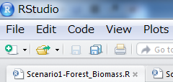

* Navigate to a working folder and click R Code folder (Desktop/treebiomass/R Code)
* Click “Scenario1-Forest_Biomass.R”



* Now you see a sheet called “Scenario1-Forest_Biomass.R”

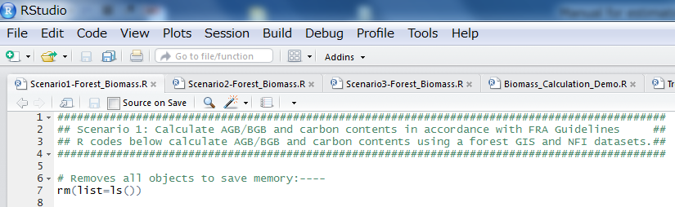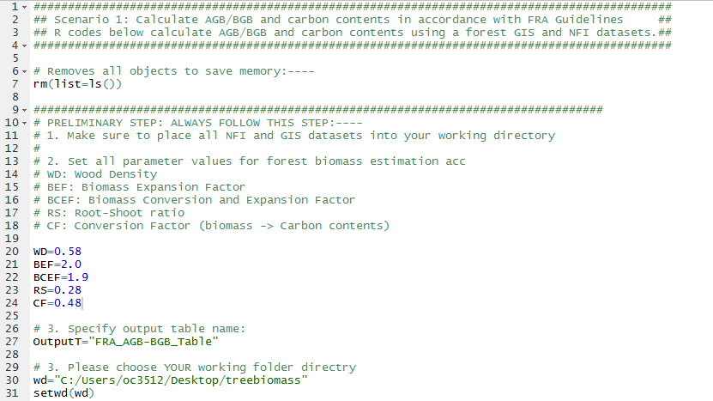

Step 1

Step 2

Step 3

* Follow steps below:

**Step 1**: set all parameter values for wood density (WD), BEF (Biomass Expansion Factor) or BCEF (Biomass Conversion and Expansion Factor), RS (Root-Shoot ratio), and CF (Conversion factor)

**Step 2**: name output table for forest biomass

**Step 3**: Specify your working directory (be careful with direction of slash):

(X) ~~C:\Users\oc3512\Desktop\treebiomass~~

(〇) C:/Users/oc3512/Desktop/treebiomass

(〇) C:\\Users\\oc3512\\Desktop\\treebiomass

**Step 4**: Go to Click -> Run Region -> Run All or (Ctrl+Alt+R)

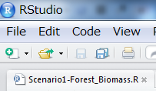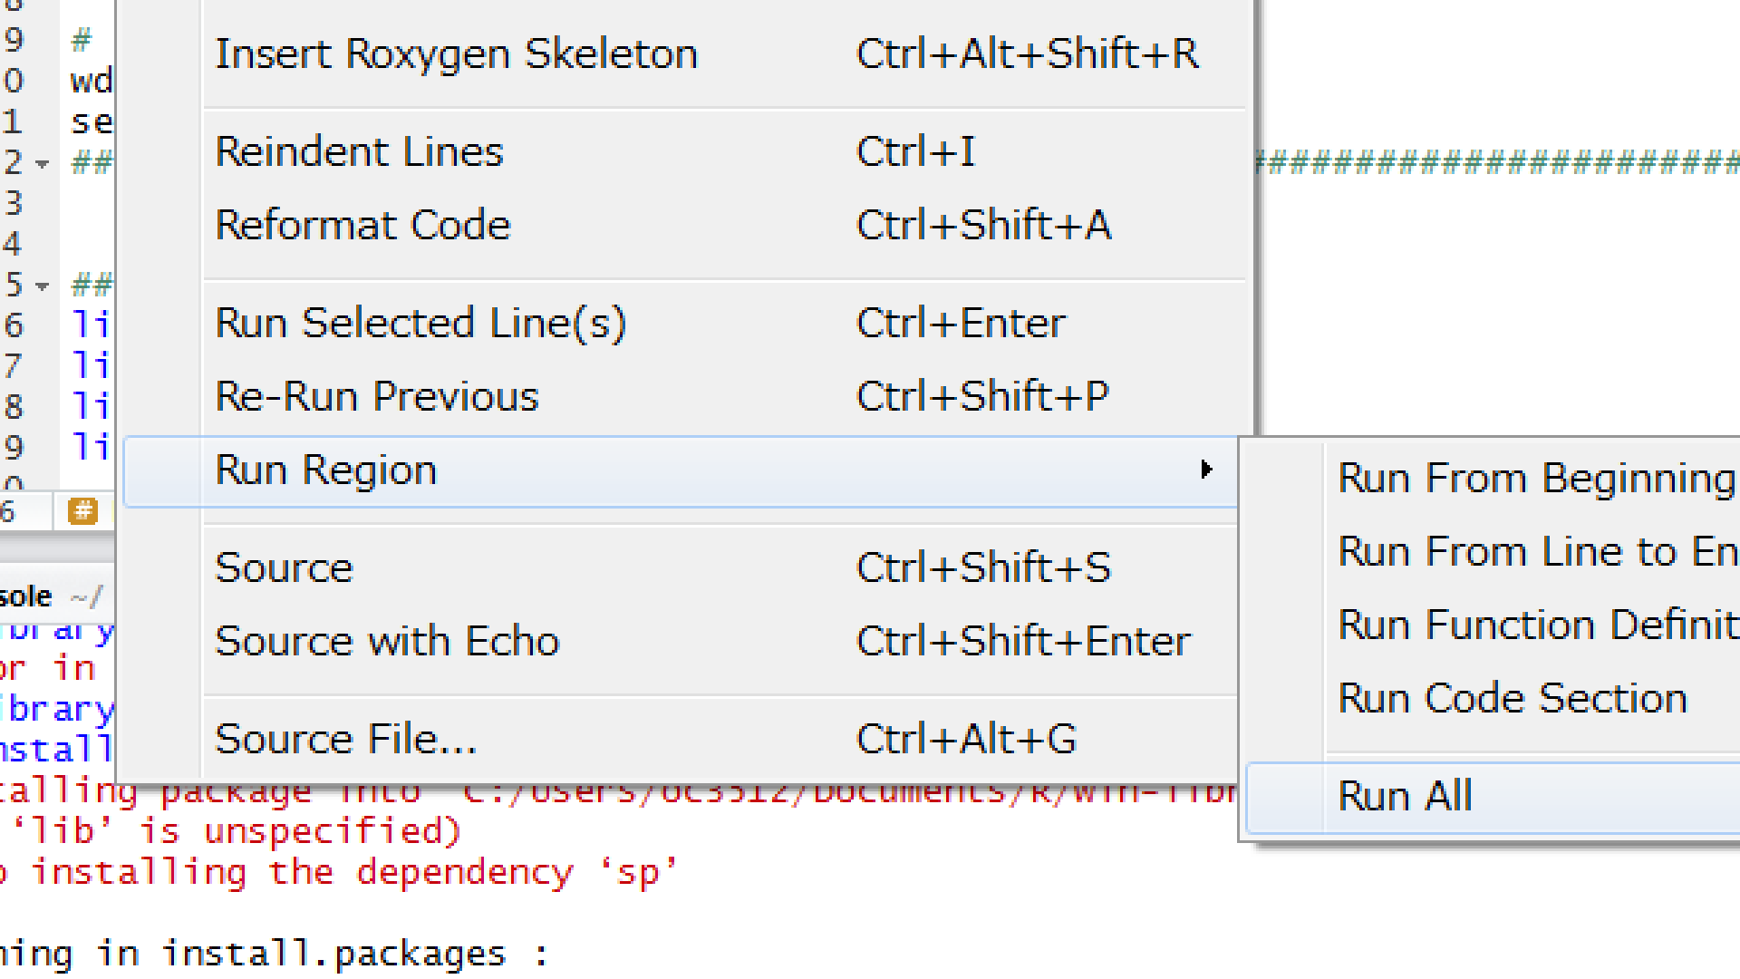

### Step-by-Step Description of Codes:

Now let’s try to type R codes you have just run in the upper left window of RStudio. Make sure to understand what, how, and why the R codes are used. But first, I will explain one-by-one.

### Set Working Directory and Parameters



*rm(list=ls())* simply removes all objects stored in this current active R windows

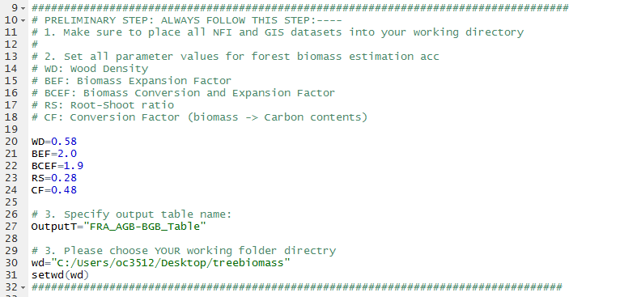

* Set parameters for WD (wood density), BEF (Biomass Expansion Factor) or BCEF (Biomass Conversion & Expansion Factor), RS (Root-Shoot ratio), and CF (Conversion Factor)
* Specify output table name that will be used at the end of command lines when the table is exported
* Specify working directory where all datasets and outputs will be stored

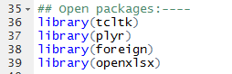

* Open above 4 packages

## Area of Forest and Woodland

### Open a GIS database (.dbf)



* *list.files* : automatically choose files in the working folder (treebiomass) that include specified letters (here, “FDM” or “.dbf”)
* *read.dbf()* : And read a file that matches one specified in the above *list.files()*

### Calculate areas by land classification types



* *ddply():* sum areas by class
* *colnames():* simply change names for ease of interpretation

After you run the codes above, you will see outputs like below.

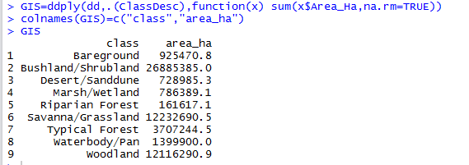

### Convert ha to ‘000 ha

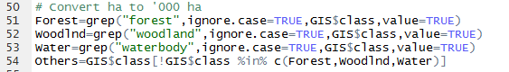

* *grep()*: selects only class names that contain “forest”, otherwise ignored. In this case, we selected “Typical Forest” and “Riparian Forest”.
* The same is true for “woodland” and “waterbody”
* *‥%in%‥*: selects all class names other than “forest”, “woodland”, and “waterbody”

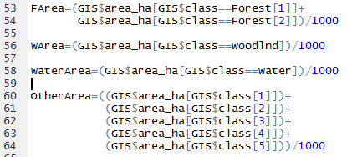

* Because we need a unit ‘000 ha, divide area-per-ha by 1000 for each category



* Calculate total area by adding areas of all categories

## Total Forest Growing Stock

### Read inventory data and prepare for analysis

* Combine and Read inventory data



* Get a list of all NFI files in the working folder
* *list.files()*: lists all files stored in *wd* (working folder)



* In this example, we have only three NFI data tables (NFI 1, NFI 2, and NFI 3).

Continued….

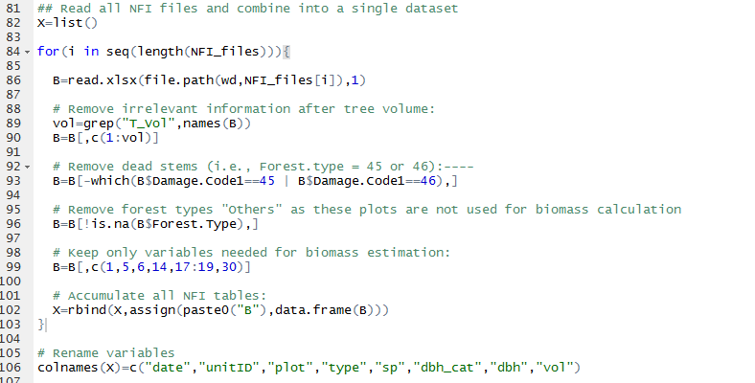

* *list()*: make an empty storage space for accumulating all NFI datasets
* *for*: this is a loop function. Because there are 3 NFI datasets, *for* function repeats process inside the loop three times.
* *read.xlsx()*: NFI files are .xlsx format.
* *grep()*

*B[,c(1:vol)]*: *grep* captures only column names that match specified pattern. In NFI datasets, there are some unnecessary column names beyond tree volume. These 2 commands delete those unwanted names and observations

* *B[-which(B$Damage.Code1‥‥*: this code eliminates observations where trees are dead.
* *B[!is.na(B‥‥:* this code eliminates observations where forest type is “others”
* *B[, c(1,5,6,14‥‥*: this code keeps only column names that are needed to calculate forest biomass
* *rbind()*: this accumulates and combines all NFI datasets into a single dataset
* *colnames()*: change column names for ease of interpretation

### Mean volume per hectare of Unit ID

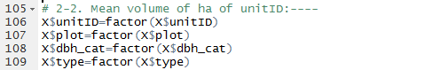

* *factor()*: convert character to factor type, which is necessary for applying *ddply* function below.

### Total volume of each DBH category



* *ddply():*note we must use cascading orders when calculating total volume of each DBH category. This is because DBH category falls within plot which falls within forest type which falls within unitID. Please recall a calculation step using EXCEL spreadsheet.

### Volume per hectare of each DBH category

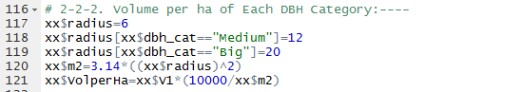

* *xx$radius‥‥:* this code specify radius (in meter) for each small, medium, and big circular plots.
* *xx$m2:* we need area (m2) of each circle for estimating volume per ha
* *xx$volperHa:* calculates volume per ha of each DBH category

### Total volume per ha of Each UNIT ID, and Each Plot



* *ddply():* sum of volume-per-ha values of small, medium, and big plots

### Identify a Dominant Land Cover Type for Each Unit ID

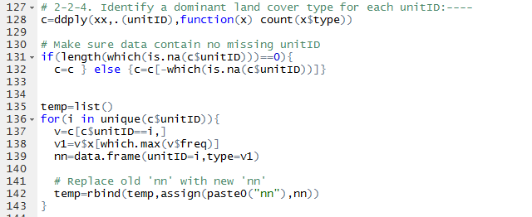

* All the codes above are written for identifying dominant forest cover type (either Forest or Woodland) for unitID.
* *ddply():* count how many Forest or Woodland types for each unitID
* *for‥‥:* this code votes which cover type dominates (or wins) for each unitID, Forest or Woodland? Remember that if a unitID has two Forest plots and one Woodland plot, this unitID is identified as Forest.

### Calculate Mean Volume per Hectare of Unit ID



* Ddply(): calculates mean volume per ha for each unitID.

### Add Identified Forest Type to Volume Data



* *merge():* once each unitID is identified as Forest or Woodland, this code merges those information to original dataset.

### Mean Volume per Hectare by Forest Type



* *ddply():* calculate mean volume per ha by forest type (Forest and Woodland)

### Calculate Total Forest Growing Stock (million m3)

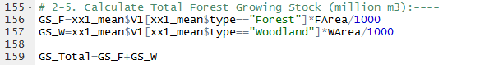

* The codes above calculate total forest growing stock (in a unit of million m3) by forest type (Forest and Woodland)

## AGB/BGB Biomass

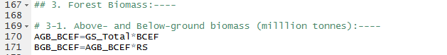

* AGB_BCEF: computes aboveground biomass using BCEF (Biomass Conversion and Expansion Factor)
* BGB_BCEF: computes belowground biomass using aboveground biomass & RS (Root-Shoot ratio)

## Carbon in AGB/BGB (million tonnes)



* AGB_C computes aboveground carbon using CF (Carbon Fraction)
* BGC_C computes belowground carbon using CF

### Generate a Table that Contains All Information

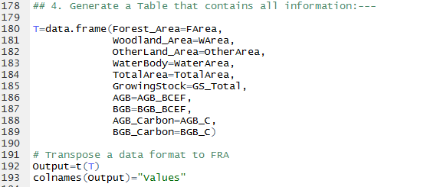

* T combines all the calculated information necessary for FRA report.
* *t()*: transposes data alignment from row wise to column wise, vice versa.

## Export Output Table



* *write.csv*: saves the above table into our working folder.

# Appendix

# A list of R packages and functions used for estimating AGB/BGB during the workshop

Table A 1 A list of R packages used for estimating AGB/BGB

|  |  |
| --- | --- |
| R package | Description |
| arcgisbinding | bridge between R and ArcGIS (ArcMap or ArcGIS Pro) |
| base | Provide a wide variety of base functions |
| foreign | Read files in a variety of formats (e.g., dbf) |
| installr | Gives the user the option to download software from within R |
| lattice | It is a powerful and elegant high-level data visualization system with an emphasis |
| openxlsx | Reading, writing, and editing Excel data in xlsx format |
| plyr | Break down data into pieces (e.g., for data summary) |
| rgdal | Read a file geodatabase of ArcGIS |
| tcltk | Provide access to user-defined directory and/or file(s) and useful for selecting multiple files (e.g., three excel files) |

Table A 2 A list of functions in the corresponding R packages used for estimating AGB/BGB

|  |  |  |
| --- | --- | --- |
| Functions | R package | Description |
| .libPaths() |  | gives a directory path where R packages are stored |
| assign | base | Assign a value to a name in an environment (used to accumulate data frame for this workshop) |
| choose.dir | utils | Choose directory |
| count | base | Gives the number |
| data.frame | base | Create data frame (functions similar to Excel sheet) |
| ddply | plyr | Break down data into pieces by selected variables |
| file.choose | base | Choose a file (only a single file) |
| file.path | base | Construct the path to a file from components in a platform-independent way (e.g., file.path (‘a’,’b’,’c’) constructs C://a//b//c) |
| for | base | Used for a loop function (i.e., useful to repeating tasks) |
| function | base | Create a user-defined function |
| list | base | Store an ordered collection of objects |
| mean | base | calculate a mean |
| merge | base | Merge two data frames by common columns or row names |
| paste0 | base | Concatenate vectors after converting to character |
| rbind | base | Combine a sequence of vector, matrix, or data frame by rows |
| read.dbf | foreign | Read data in the dbf format |
| setwd | base | Set working directory in the current R window |
| tk_choose.files | tcltk | Specify and store file(s) location as object |
| unique | base | Returns a vector or data frame but with duplicate elements/rows removed |
| which | base | Identify rows that meet a specific condition |
| write.csv | utils | Save in .csv format |
| openxlsx | openxlsx | Open Excel file (.xlsx) |
| list.files | base | list all files within a specified folder |
| grep | base | search for matches to a pattern |

# Three Scenarios for Estimating AGB/BGB

There are 3 scenarios prepared for quantifying AGB/BGB. We used Scenario 1 which required minimal intervention in ArcGIS operation. But there are other approaches for the calculation. The table below is a list of available scenarios designed and prepared in Appendix. You can familiarize yourself with the hardware and technical difference between three scenarios.

Table ‑ List of available scenarios for biomass estimation with relative dependencies of R and ArcGIS operations. ◎:Heavy reliance, 〇: Normal, △: Neglible

|  |  |  |  |  |
| --- | --- | --- | --- | --- |
| Scenario | 1 | 2 | 3 | Note |
| R | ◎ | ◎ | △ | The latest version is recommended |
| ArcGIS | △ | 〇 | ◎ | Version 10.3.1 or higher is required |
| Technical skill required | Low | Low | High | Marks are relative |
| This workshop |  | X  (Appendix) | X  (Appendix) | Participants will work with scenario 1 |

**Scenario 1** is designed to minimize intervention of ArcGIS (Figure 1).

**Scenario 3** is used to calculate biomass using almost entirely in the ArcGIS interface with very minimal intervention of R.

**Scenario 2** falls between the other two Scenarios in that R is a primary source for the biomass calculation.

## Which scenario to use?

Which scenario to use generally depends on your technical skills and hardware environment. Please follow a flow chart below for the general guidance.

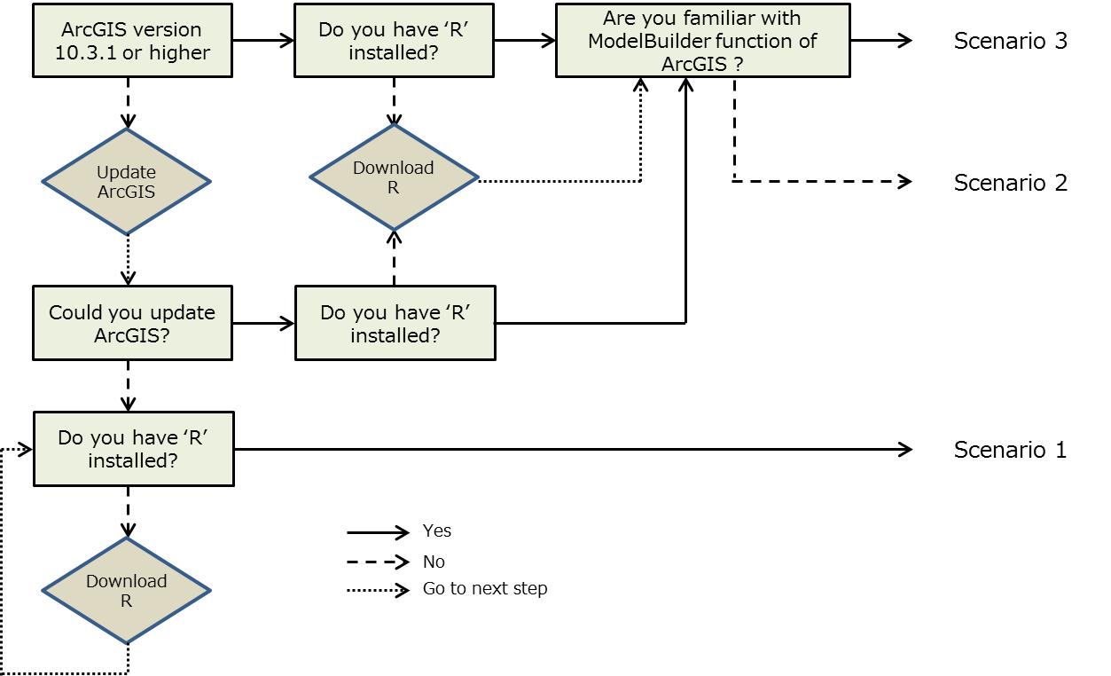

# How to Bridge R and ArcGIS

Prior to performing Scenario 2 and 3, we first need to build a connection between R and ArcGIS applications. This requires installation of specific versions of R and ArcGIS, and also some pre-settings. Please consult and complete the following procedures.

## Install R-ArcGIS Bridge

### Pre-requisites

#### Check Version of R and ArcGIS

Make sure that you have R and ArcGIS applications with the following versions:

* ArcGIS 10.3.1 or later
* R Statistical Computing Software 3.1.0 or later

#### Ensure that R is run on 32-bit

##### Open RStudio

##### Go to Tools -> Global Options

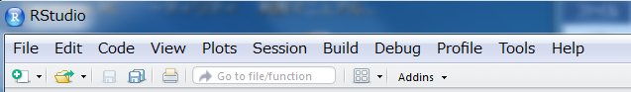

##### Check a current version of R: “R version” (in the Figure below)

##### If R version is run 64-bit, click Change and check 32-bit and click OK

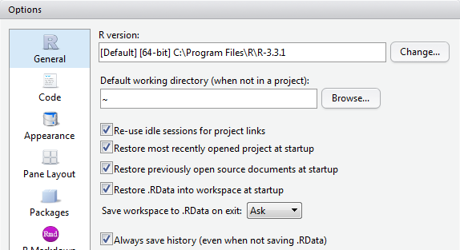

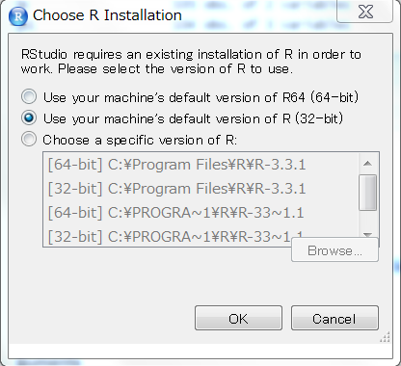

#### Install R-ArcGIS Bridge

##### **Open** [**https://github.com/R-ArcGIS/r-bridge-install#arcgis-1031**](https://github.com/R-ArcGIS/r-bridge-install#arcgis-1031)

##### Click Clone or download below

##### Choose Download ZIP

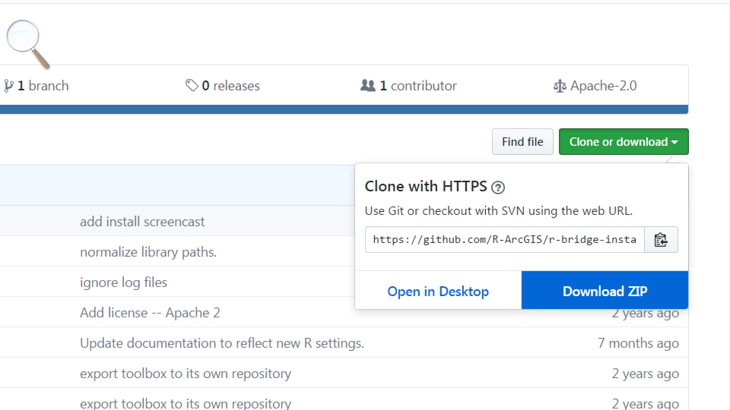

##### Extract the “r-bridge-install-master.zip” into where you wish to store the file (e.g., Desktop)

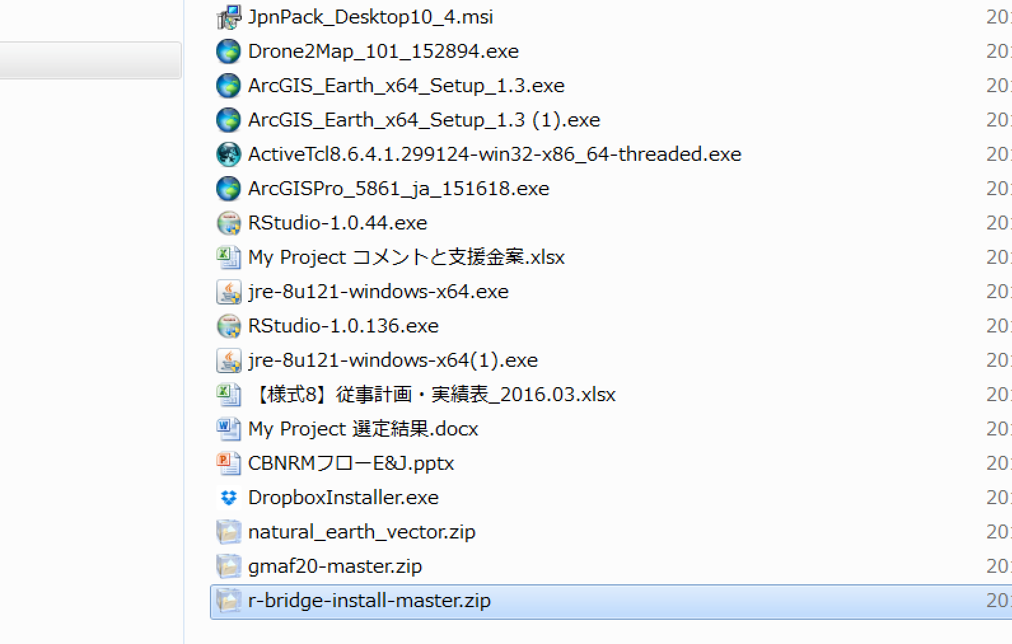

##### Open ArcMap

##### Open Catalog from within the ArcMap

##### Open r-bridge-install folder and extend “R Integration.pyt”

##### Double-click and run “Install R bindings”

##### Wait until installation is complete

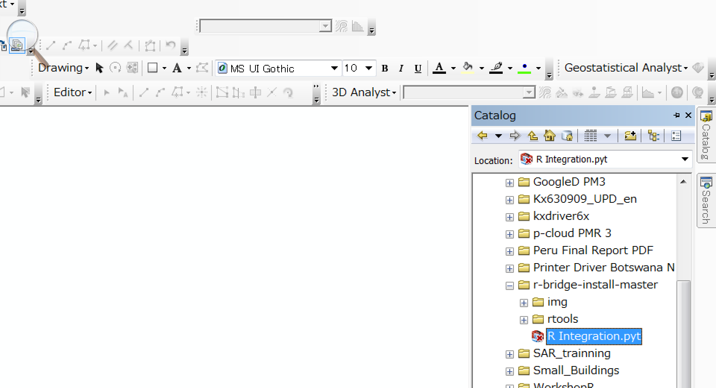

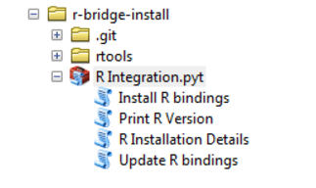

#### Check R-ArcGIS Connection

##### Open RStudio

##### Type and run *library(arcgisbinding)* like below:

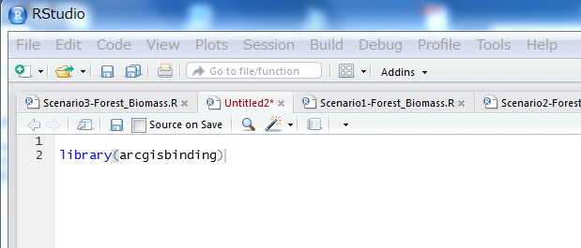

##### In the console window, you will see the following notes: “*** Please call arc.check_product() to define a desktop license.”

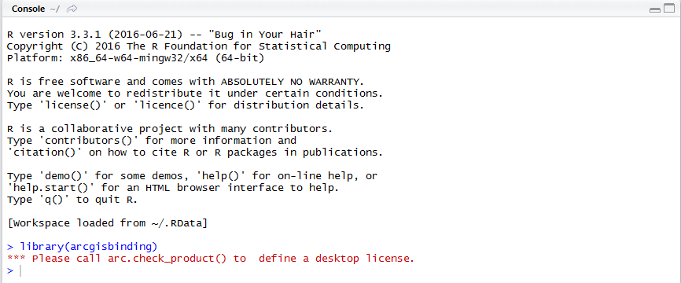

##### Type and run arc.check_product()

##### If R-ArcGIS are properly bridged, you will see something like below: “product: ArcGIS Pro (11.3.0.5861) License: Advance”

##### If you encounter Error, this means that you did not install R-bridge properly (refer to 3.1.1.3). Re-install R-Bridge.

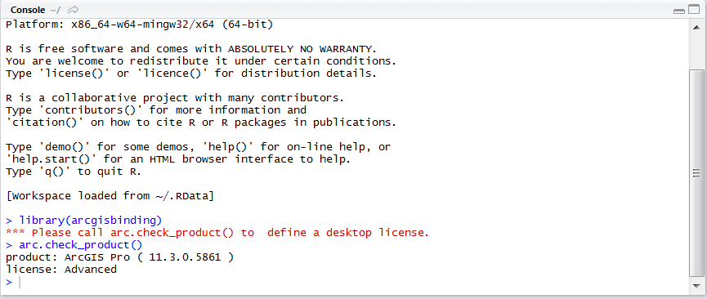

For more detailed installation procedures, please consult the following homepage: <https://github.com/R-ArcGIS/r-bridge-install#arcgis-1031>

## Scenario 1: Raw Code

The following codes are raw R codes for estimating forest biomass via Scenario 1. You can copy and paste in the Source window of RStudio.

#############################################################################################

## Scenario 1: Calculate AGB/BGB and carbon contents in accordance with FRA Guidelines ##

## R codes below calculate AGB/BGB and carbon contents using a forest GIS and NFI datasets.##

#############################################################################################

# Removes all objects to save memory:----

rm(list=ls())

###################################################################################

# PRELIMINARY STEP: ALWAYS FOLLOW THIS STEP:----

# 1. Make sure to place all NFI and GIS datasets into your working directory

#

# 2. Set all parameter values for forest biomass estimation acc

# WD: Wood Density

# BEF: Biomass Expansion Factor

# BCEF: Biomass Conversion and Expansion Factor

# RS: Root-Shoot ratio

# CF: Conversion Factor (biomass -> Carbon contents)

WD=0.58

BEF=2.0

BCEF=1.9

RS=0.28

CF=0.48

# 3. Specify output table name:

OutputT="FRA_AGB-BGB_Table"

# 3. Please choose YOUR working folder directry

wd="C:/Users/oc3512/Desktop/treebiomass"

setwd(wd)

##################################################################################

## Open packages:----

library(tcltk)

library(plyr)

library(foreign)

library(openxlsx)

## 1- Area of Forest and Woodland:----

# Open a GIS database (.dbf)

gis_db=list.files(wd,pattern="FDM|.dbf")

dd=read.dbf(file.path(wd,gis_db))

GIS=ddply(dd,.(ClassDesc),function(x) sum(x$Area_Ha,na.rm=TRUE))

colnames(GIS)=c("class","area_ha")

# Convert ha to '000 ha

Forest=grep("forest",ignore.case=TRUE,GIS$class,value=TRUE)

Woodlnd=grep("woodland",ignore.case=TRUE,GIS$class,value=TRUE)

Water=grep("waterbody",ignore.case=TRUE,GIS$class,value=TRUE)

Others=GIS$class[!GIS$class %in% c(Forest,Woodlnd,Water)]

FArea=(GIS$area_ha[GIS$class==Forest[1]]+

GIS$area_ha[GIS$class==Forest[2]])/1000

WArea=(GIS$area_ha[GIS$class==Woodlnd])/1000

WaterArea=(GIS$area_ha[GIS$class==Water])/1000

OtherArea=((GIS$area_ha[GIS$class[1]])+

(GIS$area_ha[GIS$class[2]])+

(GIS$area_ha[GIS$class[3]])+

(GIS$area_ha[GIS$class[4]])+

(GIS$area_ha[GIS$class[5]]))/1000

# Calculate total area by summing above:

TotalArea=FArea+WArea+OtherArea+WaterArea

## 2- Total Growing Stock:----

# 2-1. Read Inventory dataset and Prepare Data:----

# Combine and Read inventory data

## List all files inside our working folder

NFI_files=list.files(wd,pattern = c("NFI","xlsx"))

## Read all NFI files and combine into a single dataset

X=list()

for(i in seq(length(NFI_files))){

B=read.xlsx(file.path(wd,NFI_files[i]),1)

# Remove irrelevant information after tree volume:

vol=grep("T_Vol",names(B))

B=B[,c(1:vol)]

# Remove dead stems (i.e., Forest.type = 45 or 46):----

B=B[-which(B$Damage.Code1==45 | B$Damage.Code1==46),]

# Remove forest types "Others" as these plots are not used for biomass calculation

B=B[!is.na(B$Forest.Type),]

# Keep only variables needed for biomass estimation:

B=B[,c(1,5,6,14,17:19,30)]

# Accumulate all NFI tables:

X=rbind(X,assign(paste0("B"),data.frame(B)))

}

# Rename variables

colnames(X)=c("date","unitID","plot","type","sp","dbh_cat","dbh","vol")

head(X);tail(X)

# 2-2. Mean volume of ha of unitID:----

X$unitID=factor(X$unitID)

X$plot=factor(X$plot)

X$dbh_cat=factor(X$dbh_cat)

X$type=factor(X$type)

# 2-2-1. Total volume of each DBH Cat.:----

xx=ddply(X,.(unitID,type,plot,dbh_cat),function(x) sum(x$vol,na.rm=TRUE))

# 2-2-2. Volume per ha of Each DBH Category:----

xx$radius=6

xx$radius[xx$dbh_cat=="Medium"]=12

xx$radius[xx$dbh_cat=="Big"]=20

xx$m2=3.14*((xx$radius)^2)

xx$VolperHa=xx$V1*(10000/xx$m2)

# 2-2-3. Total volume per ha of Each UNIT ID, and Each Plot:----

xx=ddply(xx,.(unitID,type,plot),function(x) sum(x$VolperHa,na.rm=TRUE))

# 2-2-4. Identify a dominant land cover type for each unitID:----

c=ddply(xx,.(unitID),function(x) count(x$type))

# Make sure data contain no missing unitID

if(length(which(is.na(c$unitID)))==0){

c=c } else {c=c[-which(is.na(c$unitID))]}

temp=list()

for(i in unique(c$unitID)){

v=c[c$unitID==i,]

v1=v$x[which.max(v$freq)]

nn=data.frame(unitID=i,type=v1)

# Replace old 'nn' with new 'nn'

temp=rbind(temp,assign(paste0("nn"),nn))

}

# 2-2-5. Mean Volume per ha of unitID:----

xx=ddply(xx,.(unitID),function(x) mean(x$V1,na.rm=TRUE))

# 2-3. Add identified forest type for each unitID to volume data:----

xx1=merge(xx,temp,by="unitID")

# 2-4. Mean volume per ha of forest tyep:----

xx1_mean=ddply(xx1,.(type),function(x) mean(x$V1))

xx1_mean

# 2-5. Calculate Total Forest Growing Stock (million m3):----

GS_F=xx1_mean$V1[xx1_mean$type=="Forest"]*FArea/1000

GS_W=xx1_mean$V1[xx1_mean$type=="Woodland"]*WArea/1000

GS_Total=GS_F+GS_W

## 3. Forest Biomass:----

# 3-1. Above- and Below-ground biomass (milllion tonnes):----

AGB_BCEF=GS_Total*BCEF

BGB_BCEF=AGB_BCEF*RS

# 3-2. Carbon in AGB/BGB (million tonnes):----

AGB_C=AGB_BCEF*CF

BGB_C=BGB_BCEF*CF

## 4. Generate a Table that contains all information:---

T=data.frame(Forest_Area=FArea,

Woodland_Area=WArea,

OtherLand_Area=OtherArea,

WaterBody=WaterArea,

TotalArea=TotalArea,

GrowingStock=GS_Total,

AGB=AGB_BCEF,

BGB=BGB_BCEF,

AGB_Carbon=AGB_C,

BGB_Carbon=BGB_C)

# Transpose a data format to FRA

Output=t(T)

colnames(Output)="Values"

## 5. Export results:----

write.csv(Output,file.path(wd,paste(OutputT,".csv",sep="")),row.names=TRUE)

## Scenario 2

##### First, make sure that you followed Appendix 3: How to Bridge R and ArcGIS

##### R codes are written in *Italic*.

**## Removes all objects to save memory**

*rm(list=ls())*

**## Open packages**

*library(tcltk)*

*library(plyr)*

*library(rgdal)*

*library(foreign)*

*library(xlsx)*

**##Check the R-ArcGIS connection**

*library(arcgisbinding)*

*arc.check_product()*

**## Set working directory**

*wd=choose.dir()*

*setwd(wd)*

**## Set parameters**

# Define the following parameters used for AGB/BGB calculation

### WD: Wood Density

### BEF: Biomass Expansion Factor

### BCEF: Biomass Conversion and Expansion Factor

### RS: Root-Shoot ratio

**# CF: Conversion Factor (biomass -> Carbon contents)**

*WD=0.58*

*BEF=2.0*

*BCEF=1.9*

*RS=0.28*

*CF=0.48*

### Area of Forest and Woodland

**# Choose a directory where a GIS database is stored (geodatabase)**

fgdb=choose.dir()

fc_list=ogrListLayers(fgdb)

**# Open GIS Database**

d=arc.open(file.path(fgdb,fc_list))

**# Select only variables of interests in the Field**

names(d@fields) # Extract column names

dd=arc.select(d,fields=c("Area_Ha","ClassDesc"))

GIS=ddply(dd,.(ClassDesc),function(x) sum(x$Area_Ha,na.rm=TRUE))

colnames(GIS)=c("class","area_ha")

**# Convert ha to '000 ha**

FArea=(GIS$area_ha[GIS$class=="Typical Forest"]+GIS$area_ha[GIS$class=="Riparian Forest"])/1000

WArea=(GIS$area_ha[GIS$class=="Woodland"])/1000

### Total Forest Growing Stock

#### Read Inventory dataset and Prepare Data

**# Combine and Read inventory data**

*nf=tk_choose.files()*

*B=list()*

*for(i in length(nf)){*

*B=read.xlsx(nf[i],1,stringsAsFactors=FALSE)*

**# Remove irrelevant information after tree volume:**

*vol=grep("T_Vol",names(B))*

*B=B[,1:vol]*

*B=rbind(B,assign(paste0("B"),B))*

*}*

**# Remove dead stems (i.e., Damage.Code1 = 45 and 46)**

*B=B[!(B$Damage.Code1==45|B$Damage.Code1==46),]*

**# Keep only necessary variables**

*X=B[,c(1,5,6,14,17,18,19,30)]*

**# Rename the variables**

*colnames(X)=c("date","unitID","plot","type","sp","dbh_cat","dbh","vol")*

**# Remove "Others" type (i.e., neither Forest nor Woodland)**

*X1=X[X$type!="",]*

#### Mean volume of ha of unitID

*X1$unitID=factor(X1$unitID)*

*X1$plot=factor(X1$plot)*

*X1$dbh_cat=factor(X1$dbh_cat)*

*X1$type=factor(X1$type)*

#### Total volume of each DBH Category

*xx=ddply(X1,.(unitID,type,plot,dbh_cat),function(x) sum(x$vol,na.rm=TRUE))*

**# Volume per ha of Each DBH Category**

*xx$radius=6*

*xx$radius[xx$dbh_cat=="Medium"]=12*

*xx$radius[xx$dbh_cat=="Big"]=20*

*xx$m2=3.14*((xx$radius)^2)*

*xx$VolperHa=xx$V1*(10000/xx$m2)*

**# Total volume per ha of Each UNIT ID, and Each Plot**

*xx=ddply(xx,.(unitID,type,plot),function(x) sum(x$VolperHa,na.rm=TRUE))*

#### Identify a dominant land cover type for each Unit ID

*c=ddply(xx,.(unitID),function(x) count(x$type))*

*c=c[-which(is.na(c$unitID)),]*

*temp=list()*

*for(i in unique(c$unitID)){*

*v=c[c$unitID==i,]*

*v1=v$x[which.max(v$freq)]*

*nn=data.frame(unitID=i,type=v1)*

*temp=rbind(temp,assign(paste0("nn"),data.frame(nn)))*

*}*

#### Mean Volume per ha of unitID

*xx=ddply(xx,.(unitID),function(x) mean(x$V1,na.rm=TRUE))*

#### Add identified forest type for each unitID to volume data

*xx1=xx[-which(xx$V1==0),]*

*xx1=merge(xx1,temp,by="unitID")*

### Mean volume per ha of forest type

*xx1_mean=ddply(xx1,.(type),function(x) mean(x$V1))*

*xx1_sd=ddply(xx1,.(type),function(x) sd(x$V1))*

*xx1_n=ddply(xx1,.(type),function(x) count(x$type))*

*f=data.frame(xx1_mean,sd=xx1_sd$V1,n=xx1_n$freq)*

*f$se=f$sd/sqrt(f$n)*

#### Calculate Total Forest Growing Stock (million m3)

*GS_F=f$V1[f$type=="Forest"]*FArea/1000*

*GS_W=f$V1[f$type=="Woodland"]*WArea/1000*

*GS_Total=GS_F+GS_W*

### Forest Biomass (AGB/BGB)

#### Above- and Below-ground biomass (milllion tonnes)

*AGB_BCEF=GS_Total*BCEF*

*BGB_BCEF=AGB_BCEF*RS*

#### Carbon in AGB/BGB (million tonnes)

*AGB_C=AGB_BCEF*CF*

*BGB_C=BGB_BCEF*CF*

#### Generate a Table that contains all information

*T=data.frame(GS_Total=GS_Total,Forest_Area=FArea,Woodland_Area=WArea,*

*AGB=AGB_BCEF,BGB=BGB_BCEF,AGB_Carbon=AGB_C,BGB_Carbon=BGB_C)*

### Export output table

*write.csv(T,file.path(wd,"AGB-BGB_Table.csv"),row.names=FALSe)*

## Scenario 3

* Scenario 3 is very different from the other scenarios in that biomass calculation is performed entirely on the ArcGIS interface.
* As such, Scenario 3 requires additional skills and procedural steps that need to be undertaken in the ArcGIS platform such as Modelbuilder.

### General Guideline for Biomass Calculation under Scenario 3

A schematic diagram is portrayed below to illustrate operational procedures to be followed in order to implement Scenario 3. This diagram may be used as a general guideline and checking tool.

**Check R code**

**and/or**

**ModelBuilder**

**Write R code (RStudio)**

Did you include code for areal calculation of land cover types?

Did you include code for total forest growing stock?

Did you include code for forest biomass calculation?

Did you include code for exporting a biomass output table?

**Construct “ModelBuilder” (ArcMap)**

Add “SummaryStatistics” tool

Add R script

Test run

**Did it work?**

**No**

**Yes**

Complete

### Write R Script

**## Activate R-ArcGIS Bridge**

*tool_exec=function(in_params,out_params)*

*{*

*library(tcltk)*

*library(lattice)*

*library(plyr)*

**## Specifiy Input and Output parameters**

*Inventory=in_params[[1]]*

*LandCover=in_params[[2]]*

*WD=in_params[[3]]*

*BEF=in_params[[4]]*

*BCEF=in_params[[5]]*

*RS=in_params[[6]]*

*CF=in_params[[7]]*

*result=out_params[[1]]*

### Area of Forest and Woodland

**## Open summarized GIS Database**

*d=arc.open(LandCover)*

*GIS=arc.select(d,fields="*")*

*colnames(GIS)=c("n","class","frequency","Area_Ha")*

***## Convert m2 to '000 ha***

*FArea=(GIS$Area_Ha[GIS$class=="Typical Forest"]+GIS$Area_Ha[GIS$class=="Riparian Forest"])/1000*

*WArea=(GIS$Area_Ha[GIS$class=="Woodland"])/1000*

### Total Forest Growing Stock

#### Read Inventory Data

*B=read.csv(Inventory,header=TRUE,stringsAsFactors = FALSE)*

## Another option: combine multiple inventory tables

*########################*

*# nf=tk_choose.files()*

*# B=list()*

*# for(i in length(nf)){*

*# B=read.xlsx(nf[i],1,stringsAsFactors=FALSE)*

*# Remove irrelevant information after tree volume:*

*# vol=grep("T_Vol",names(B))*

*# B=B[,1:vol]*

*# B=rbind(B,assign(paste0("B"),B))*

*# }*

*#########################*

**## Remove standing dead (i.e., Damage.Code1 = 45 and 46)**

*B=B[!(B$Damage.Code1==45|B$Damage.Code1==46),]*

**## Keep only necessary variables**

*X=B[,c(1,5,6,14,17,18,19,30)]*

**## Rename the variables**

*colnames(X)=c("date","unitID","plot","type","sp","dbh_cat","dbh","vol")*

**# Remove "Others" type (i.e., neither Forest nor Woodland)**

*X1=X[X$type!="",]*

#### Mean volume of ha of unitID

*X1$unitID=factor(X1$unitID)*

*X1$plot=factor(X1$plot)*

*X1$dbh_cat=factor(X1$dbh_cat)*

*X1$type=factor(X1$type)*

#### Total volume of each DBH Category

*xx=ddply(X1,.(unitID,type,plot,dbh_cat),function(x) sum(x$vol,na.rm=TRUE))*

**## Volume per ha of Each DBH Category**

*xx$radius=6*

*xx$radius[xx$dbh_cat=="Medium"]=12*

*xx$radius[xx$dbh_cat=="Big"]=20*

*xx$m2=3.14*((xx$radius)^2)*

*xx$VolperHa=xx$V1*(10000/xx$m2)*

**## Total volume per ha of Each UNIT ID, and Each Plot**

*xx=ddply(xx,.(unitID,type,plot),function(x) sum(x$VolperHa,na.rm=TRUE))*

#### Identify a dominant land cover type for each unitID

*c=ddply(xx,.(unitID),function(x) count(x$type))*

*c=c[-which(is.na(c$unitID)),]*

*temp=list()*

*for(i in unique(c$unitID)){*

*v=c[c$unitID==i,]*

*v1=v$x[which.max(v$freq)]*

*nn=data.frame(unitID=i,type=v1)*

*temp=rbind(temp,assign(paste0("nn"),data.frame(nn)))*

*}*

#### Mean Volume per ha of unitID

*xx=ddply(xx,.(unitID),function(x) mean(x$V1,na.rm=TRUE))*

#### Add identified forest type for each unitID to volume data

*xx1=xx[-which(xx$V1==0),]*

*xx1=merge(xx1,temp,by="unitID")*

#### Mean volume per ha of forest tyep

*xx1_mean=ddply(xx1,.(type),function(x) mean(x$V1))*

*xx1_sd=ddply(xx1,.(type),function(x) sd(x$V1))*

*xx1_n=ddply(xx1,.(type),function(x) count(x$type))*

*f=data.frame(xx1_mean,sd=xx1_sd$V1,n=xx1_n$freq)*

*f$se=f$sd/sqrt(f$n)*

#### Calculate Total Forest Growing Stock (million m3)

*GS_F=f$V1[f$type=="Forest"]*FArea/1000*

*GS_W=f$V1[f$type=="Woodland"]*WArea/1000*

*GS_Total=GS_F+GS_W*

### Forest Biomass

#### Above- and Below-ground biomass (milllion tonnes)

*AGB_BCEF=GS_Total*BCEF*

*BGB_BCEF=AGB_BCEF*RS*

#### Carbon in AGB/BGB (million tonnes)

*AGB_C=AGB_BCEF*CF*

*BGB_C=BGB_BCEF*CF*

#### Generate a Table that contains all information

*T=data.frame(GS_Total=GS_Total,Forest_Area=FArea,Woodland_Area=WArea,*

*AGB=AGB_BCEF,BGB=BGB_BCEF,AGB_Carbon=AGB_C,BGB_Carbon=BGB_C)*

### Export results

*arc.write(result,T)*

*return(out_params)*

*}*

## Construct ModelBuilder in ArcGIS

##### A figure below depicts a final model you will learn to create during this session. Please read and follow instructions carefully and try to question at each procedural stage why you are performing a particular step.

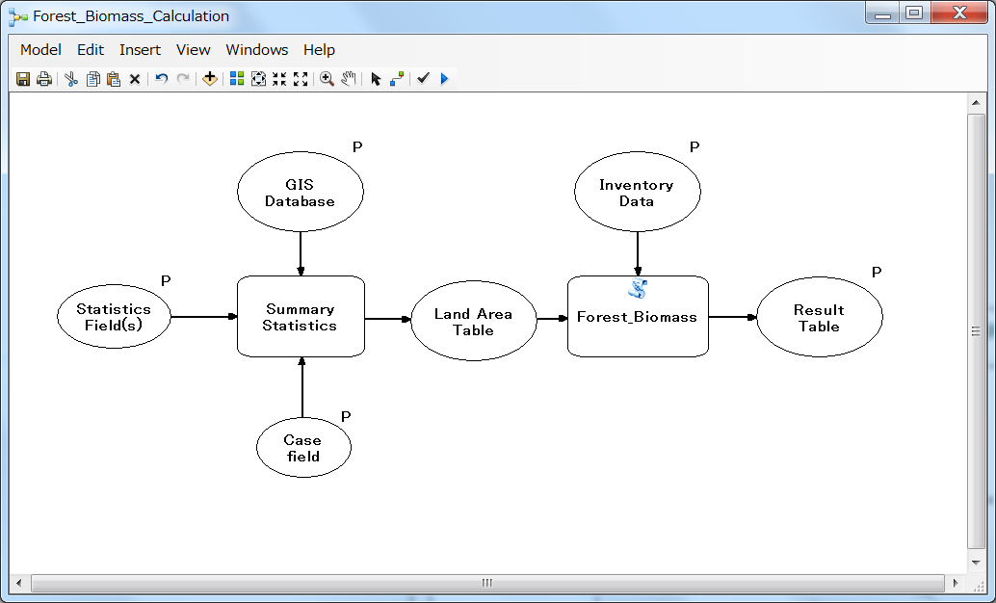

### Add GIS Database for Calculating Land Cover Areas

##### Open ArcGIS

##### Open ModelBuilder

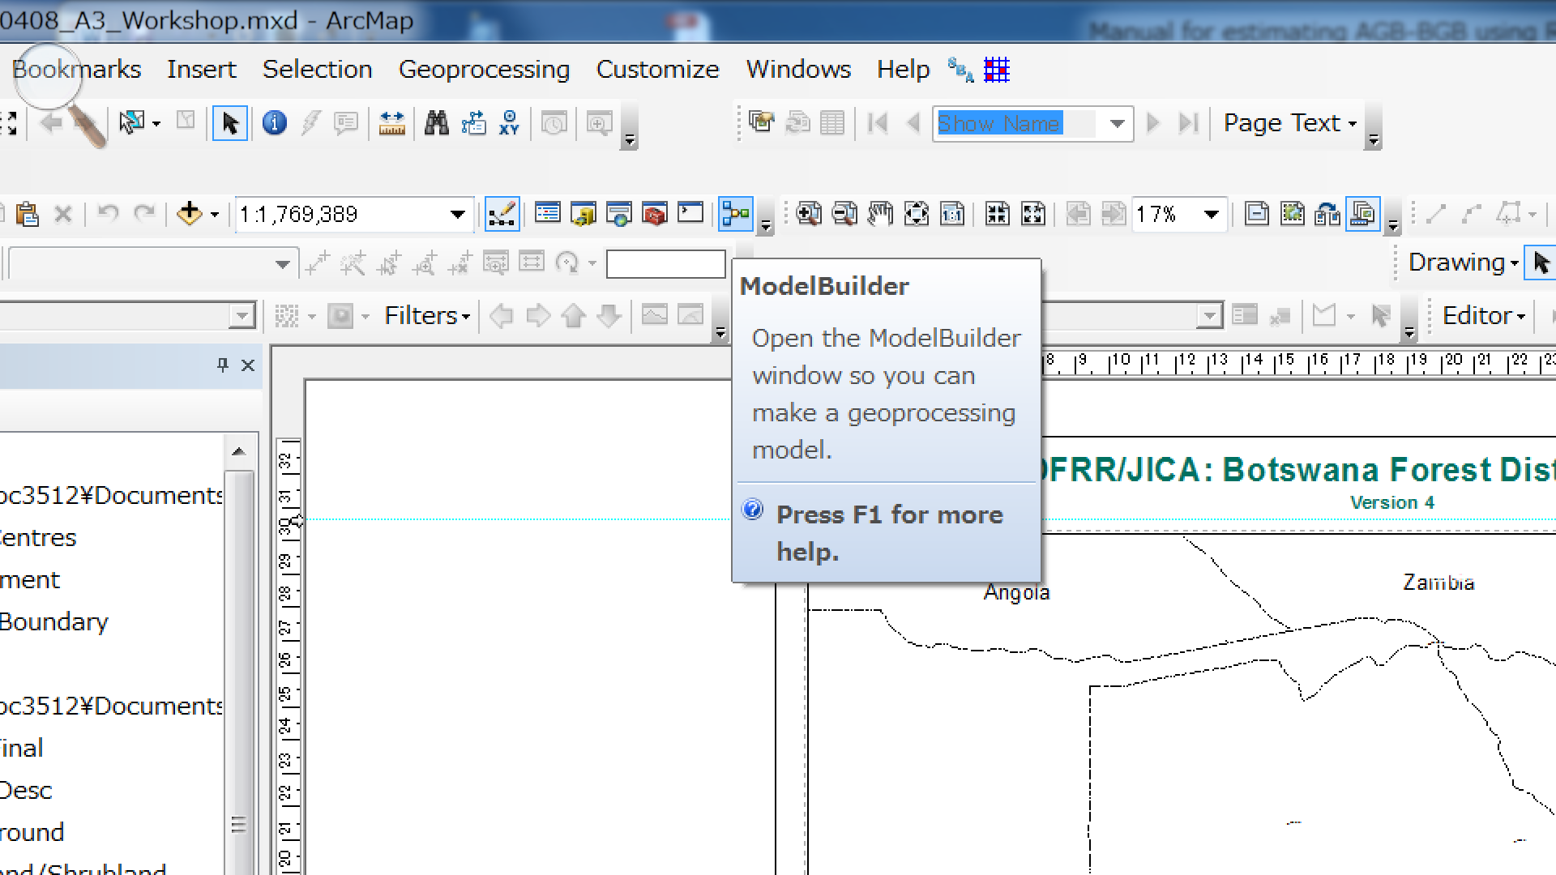

##### Go to Insert -> Add Data or Tool.. -> Toolboxes -> System Toolboxes -> Analysis Tools -> Statistics

##### Click Summary Statistics and Add (Refer to the following Figure)

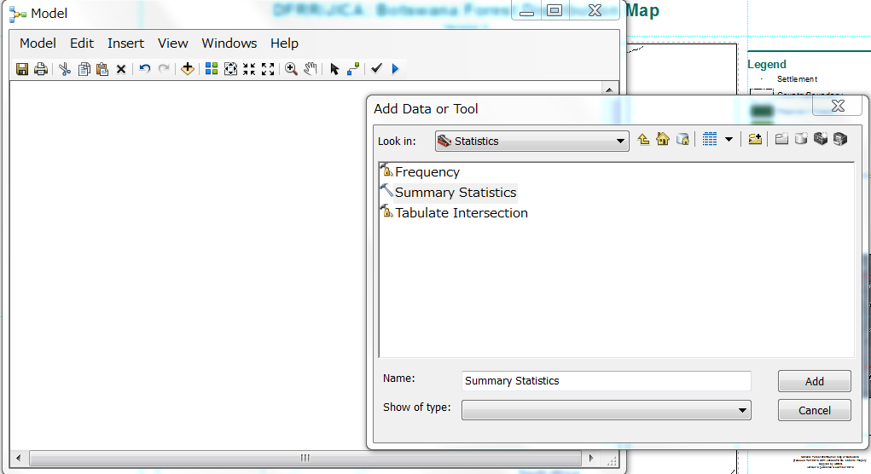

##### Add input parameters:

###### Right-click Summary Statistics -> Make Variable -> From Parameter

###### Add Input Table, Statistics Field(s), and Case field

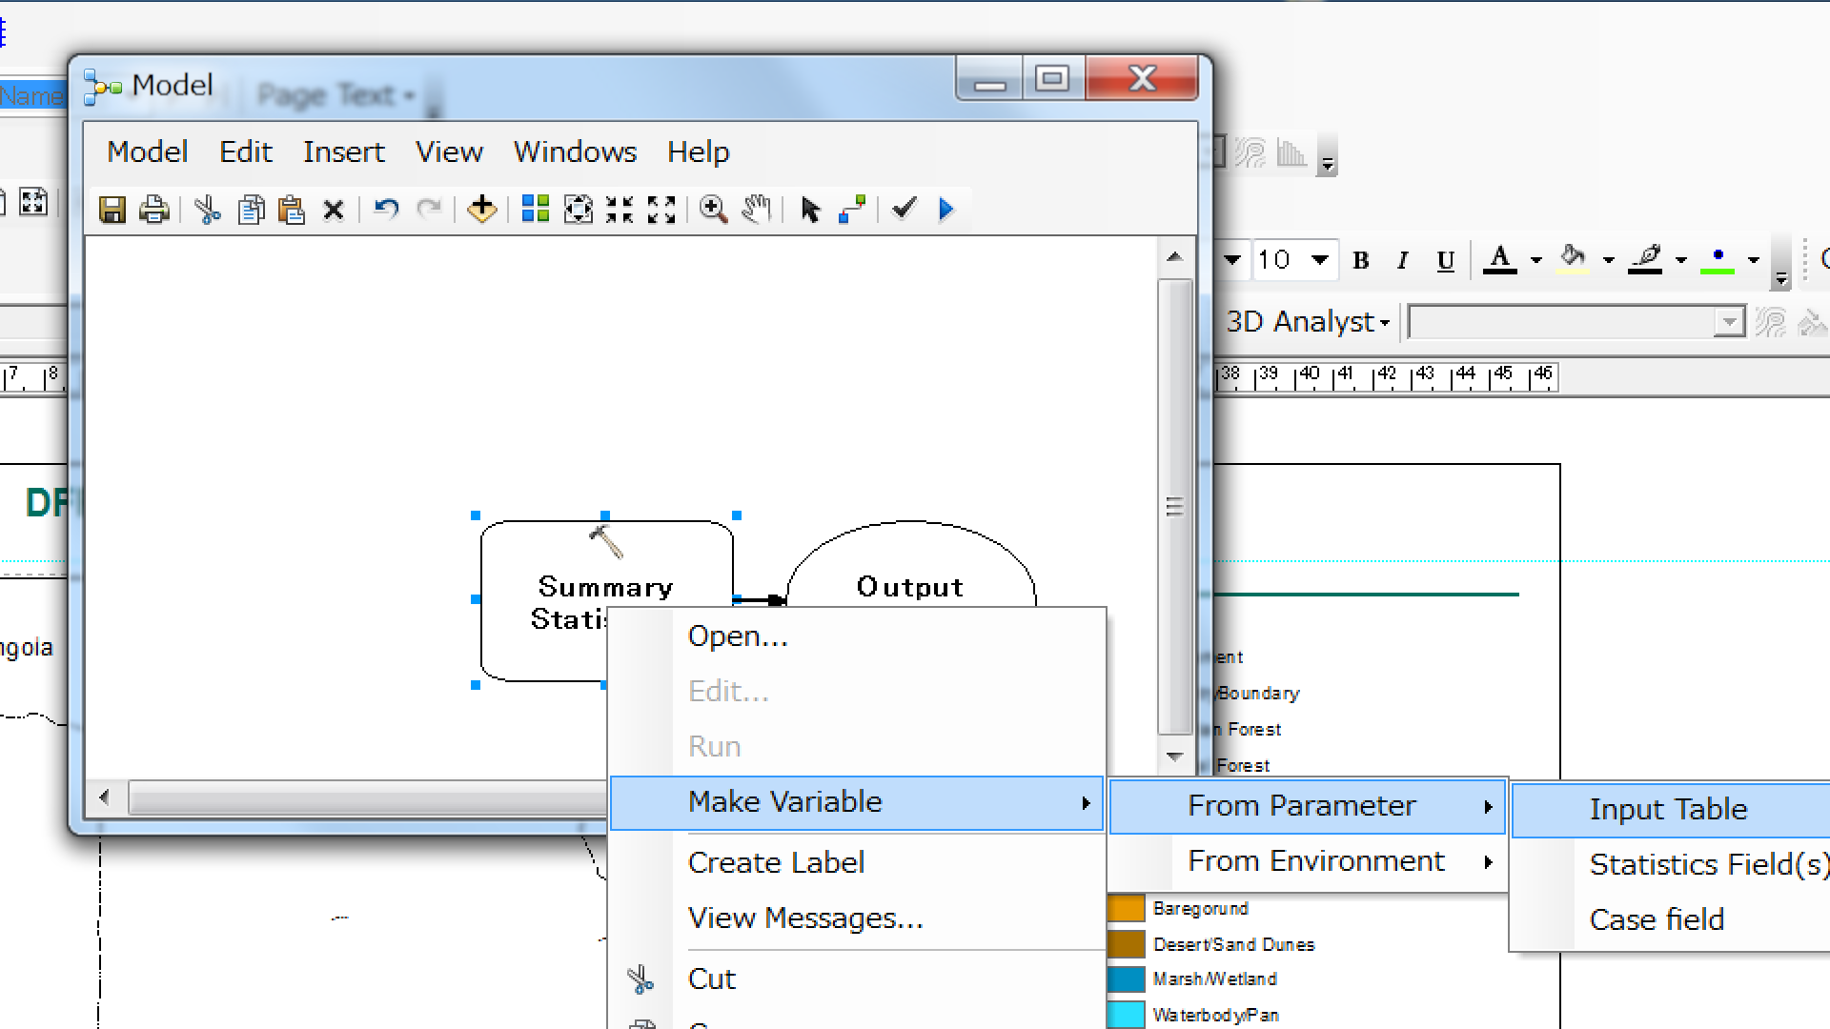

##### Ensure you add all the parameters like the following Figure

##### Each parameter is described in the table below.

|  |  |  |
| --- | --- | --- |
| Parameter | Description |  |
| Input table | The input table containing the field(s) that will be used to calculate statistics. | NFDM GIS Database |
| Statistics Field(s) | The numeric field containing attribute values used to calculate the specified statistic. | Areal field in the input table |
| Case Field (Optional) | The fields in the Input Table used to calculate statistics separately for each unique attribute value | Land cover type |
| Output Table |  | This become a summary table of land area |

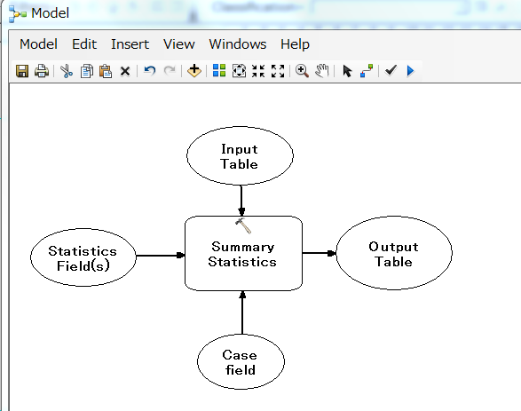

##### Rename Input Table and Output Table for ease of interpretation

###### Right-click the parameter names and Rename like the following

|  |  |
| --- | --- |
| Old parameter name | New parameter name |
| ~~Input Table~~ | GIS DB |
| ~~Output Table~~ | Land Area Table |

###### You see names of the two parameters changed like below

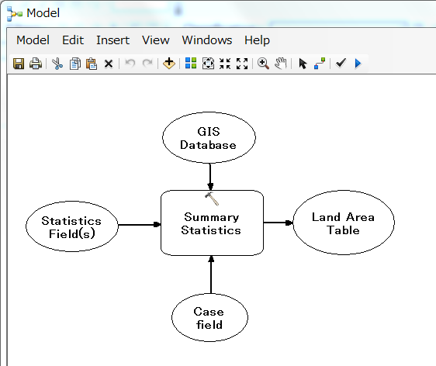

##### Save the Model in a Toolbox

###### Create a new Toolbox in your working folder in the Catalogue window of ArcMap (Right-click the folder -> New -> Toolbox)

###### Click the in the Model window and navigate to Toolbox you just created

###### Name and save the model (e.g., Figure below)

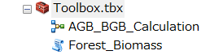

### Add NFI Dataset

##### Add R script to Toolbox

###### Right-click Toolbox in the Catalogue window -> Add script -> choose R script you created

###### Rename the R script (e.g., Forest_Biomass)

###### Make sure you added the R script under the Toolbox

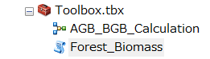

##### Set Parameters for the Forest_Biomass script and Add the script to the ModelBuilder

###### Right-click the R script (Forest_Biomass) in the Catalogue window -> Properties

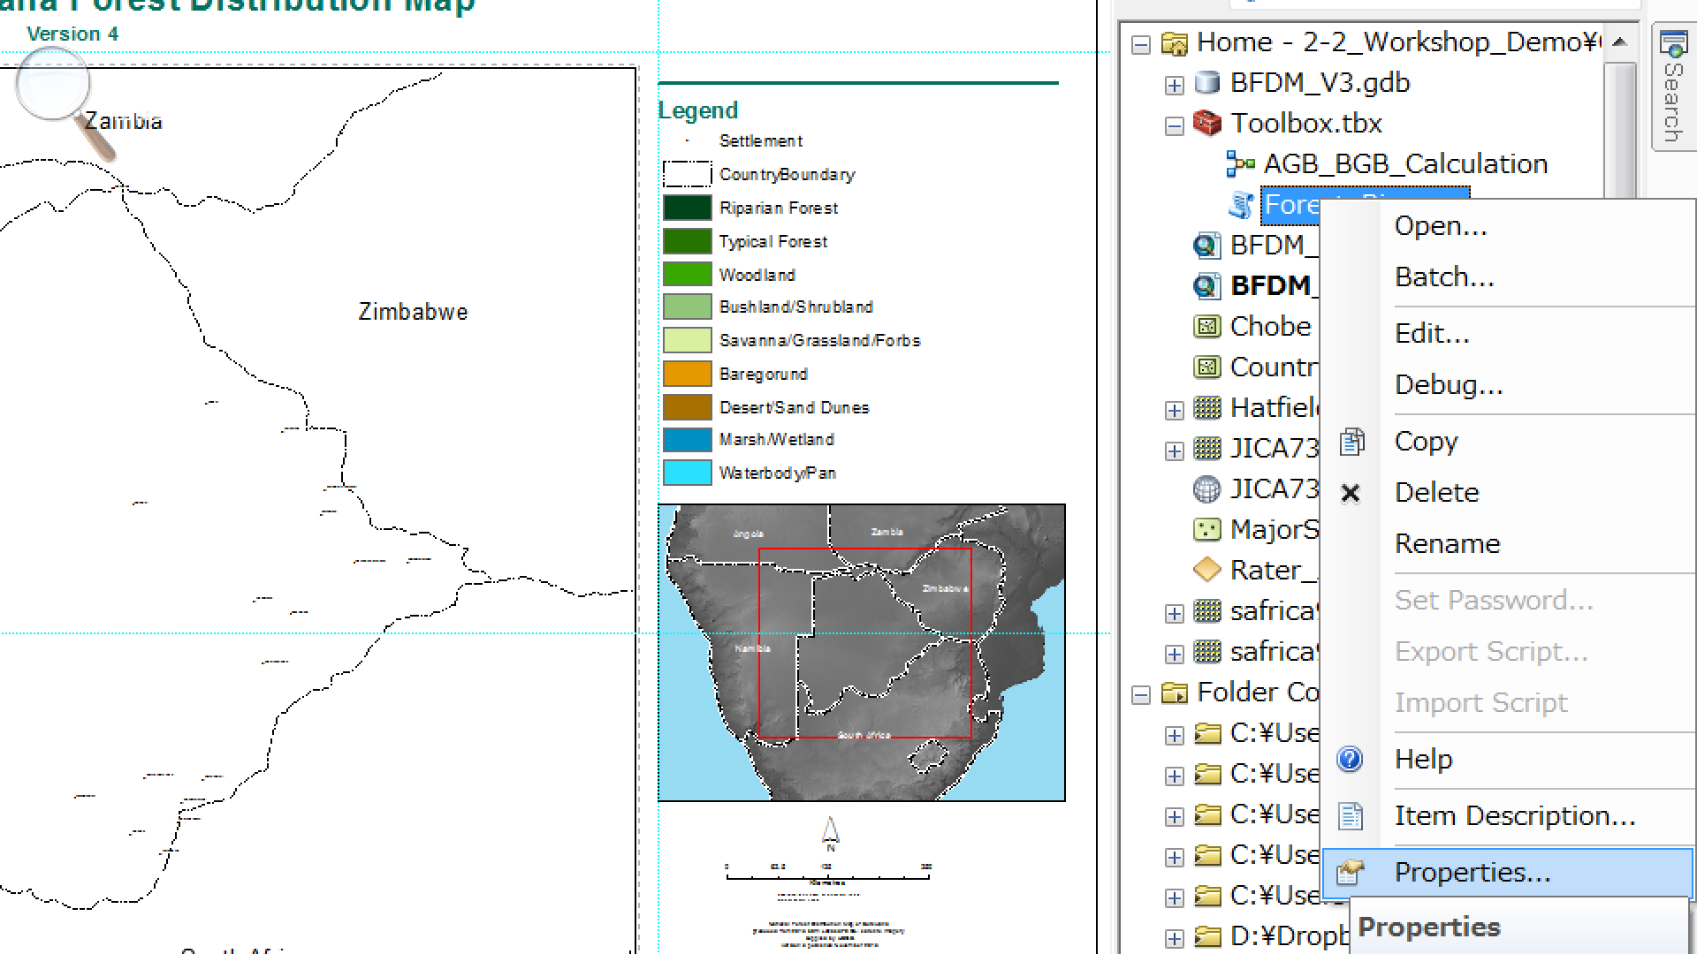

###### In the Properties window, you must enter all the parameters you specified in the Rstudio. Please fill in the Properties table according to the table below.

|  |  |  |  |
| --- | --- | --- | --- |
| Display Name | Data Type | Property | Value |
| Inventory Data | Table | Required | Input |
| Land Cover Area Table | Table | Required | Input |
| Wood Density | Double | Optional | Input |
| Biomass Expansion Factor | Double | Optional | Input |
| Biomass Conversion and Expansion Factor | Double | Required | Input |
| RootShoot Ratio | Double | Required | Input |
| Carbon Fraction | Double | Required | Input |
| Result Table | Table | Required | Output |

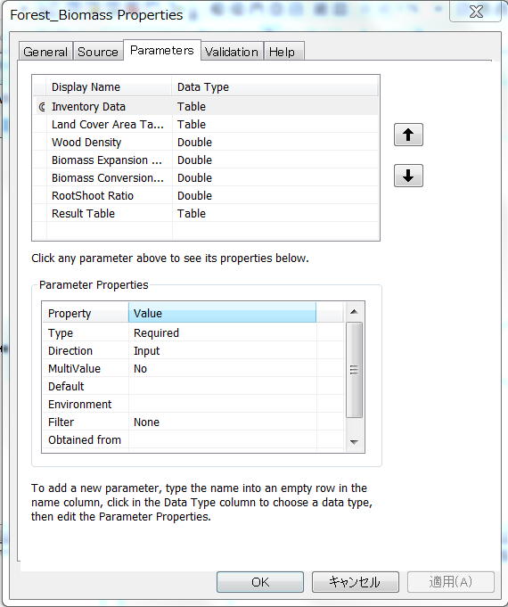

###### Drag and drop Forest_Biomass script where you set parameters to the ModelBuilder

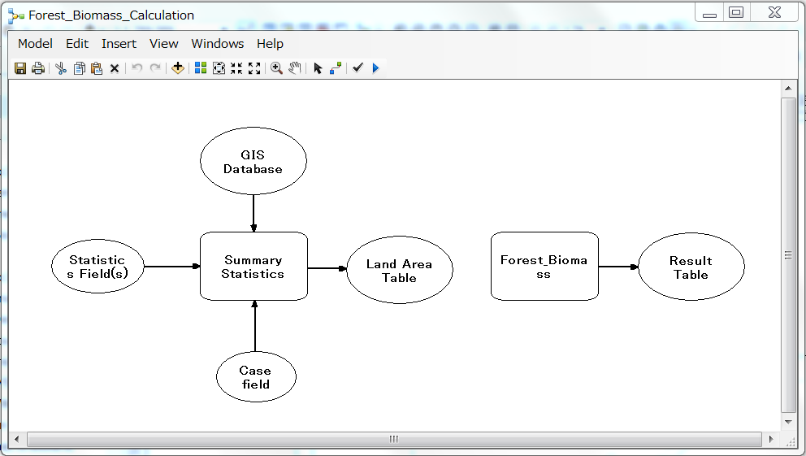

##### Design and complete ModelBuilder

###### Right-click and Open Forest_biomass properties window in the ModelBuilder

###### Fill in the following parameters according to the table below

|  |  |
| --- | --- |
| Parameter | Input value |
| Biomass Conversion and Expansion Factor | 1.9 |
| RootShoot Ratio | 0.28 |
| Conversion Factor | 0.48 |

Note the input values were chosen according to FRA Report guideline

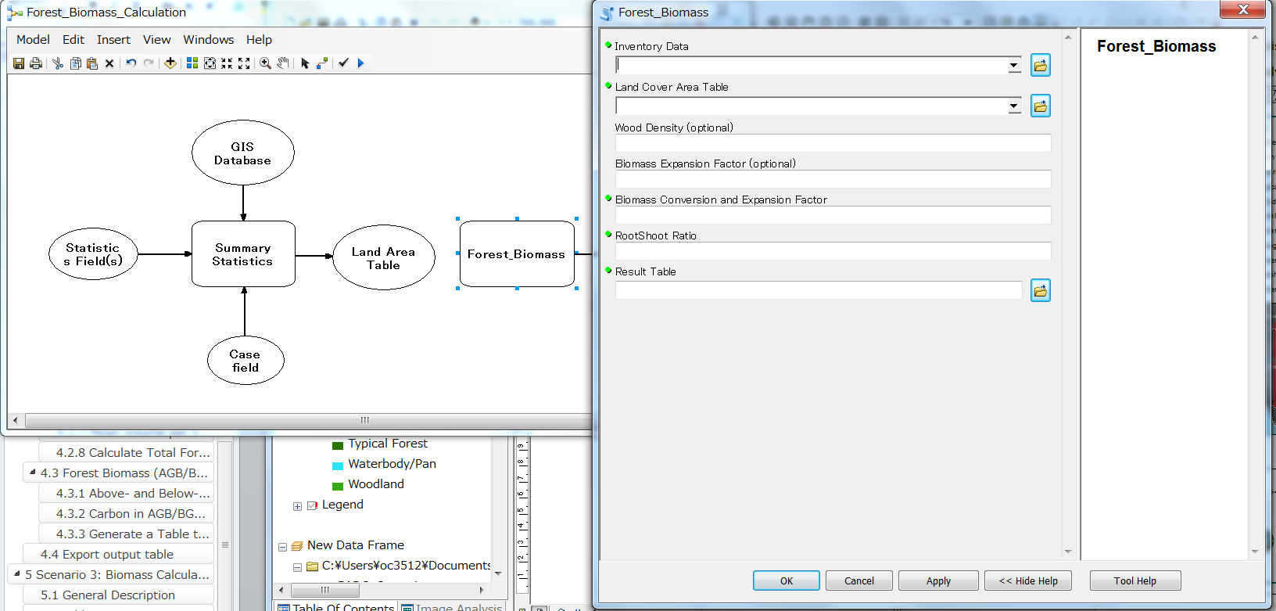

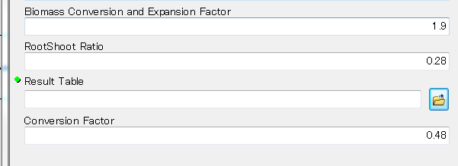

###### Add an input parameter called “Inventory Data” to the Forest_Biomass script (please refer to 3.6.1 for a specific instruction)

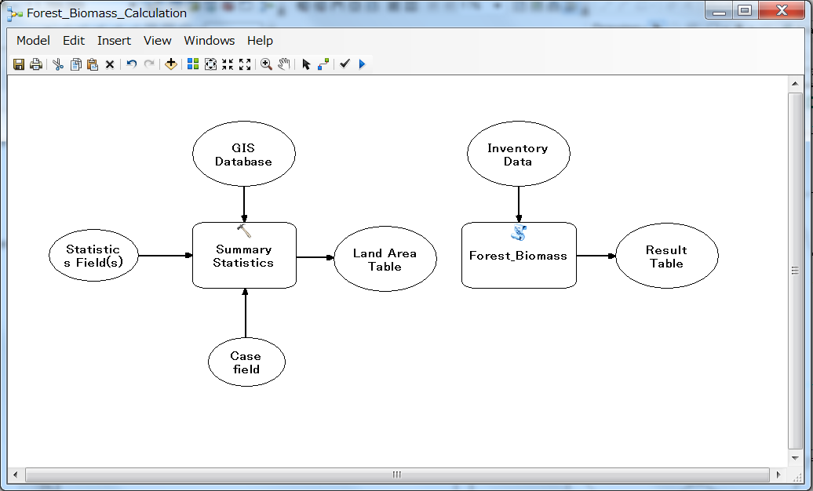

###### Connect “Land Area Table” to the Forest_Biomass property

* + Click Connect icon

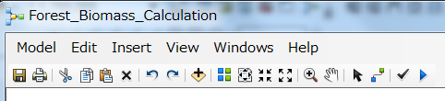

* + Connect Land Area Table to Forest_Biomass property by placing a pointer over Land Area Table, clicking and dragging the pointer to the Forest_Bioimass property (refer to a table below)
  + Release the pointer and click Land Cover Area Table

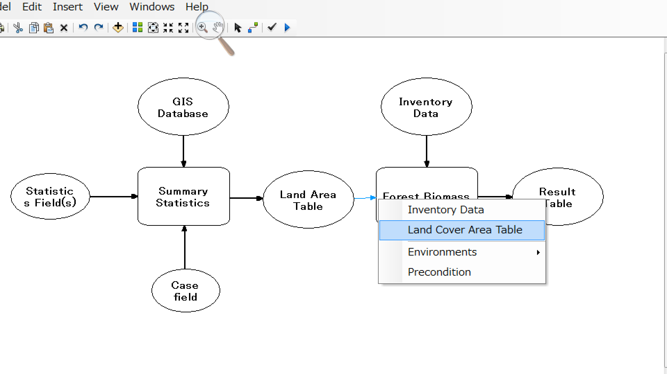

###### Turn on Model Parameters

* + Right-click over the following parameters and choose Model Parameter (see figure below): GIS Database, Statistics Field(s), Case field, Inventory Data, and Result Table

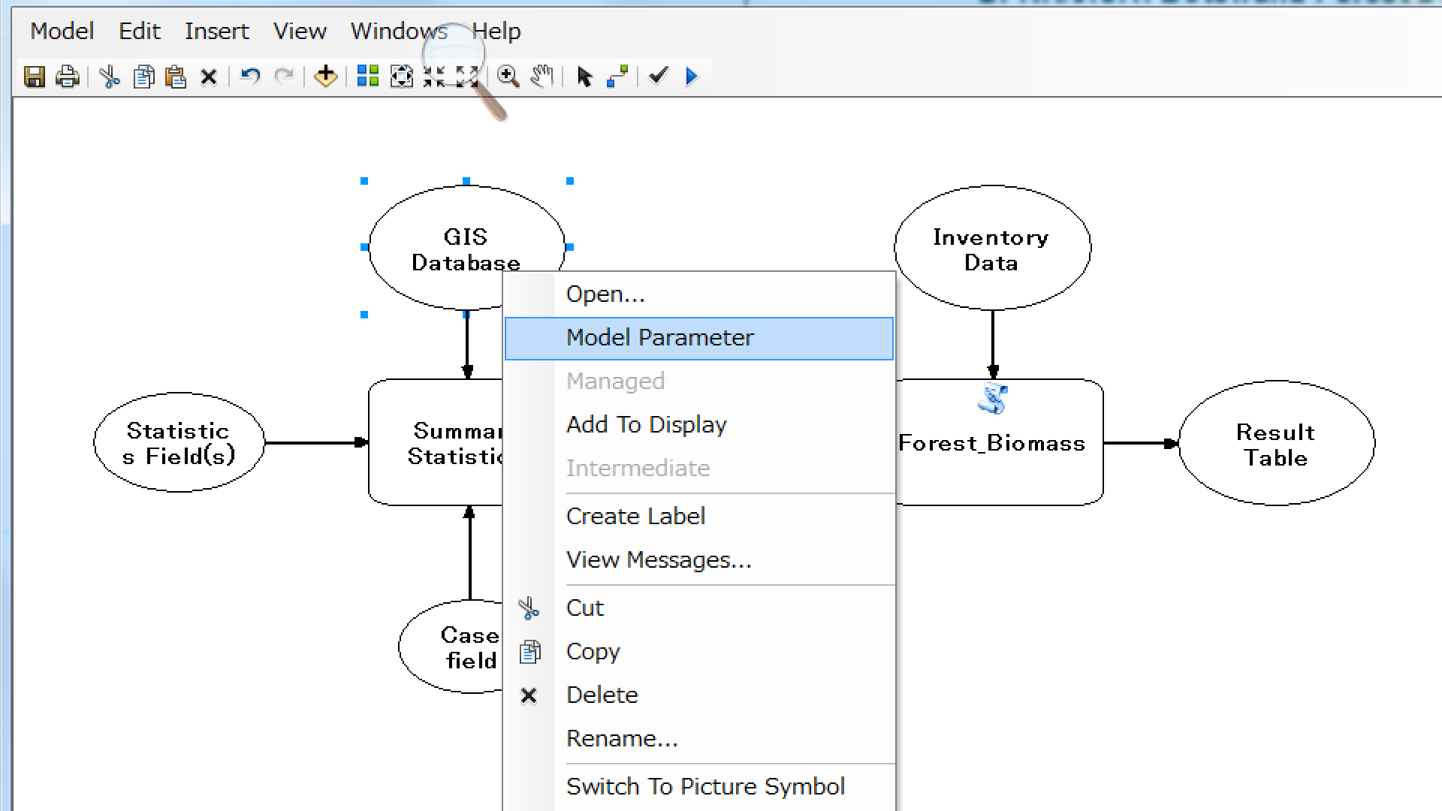

* + Make sure you see a letter “P” by the selected parameters (figure below)

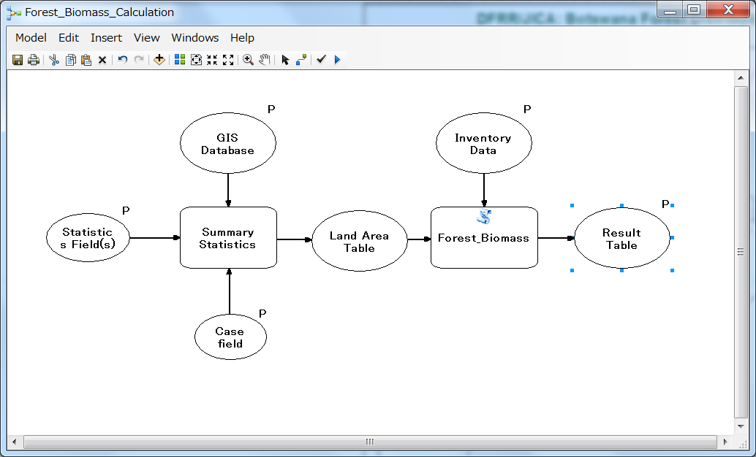

###### Test run

* + Open the ModelBuilder you have just created from within the Catalogue (see figure below)

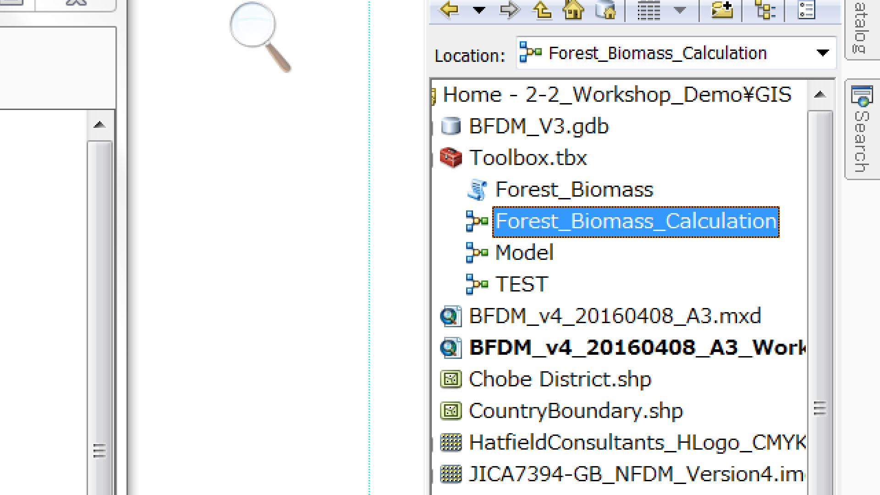

* + Choose relevant variables or attributes in the space of the property window (see figure below) by referring to a table below

|  |  |
| --- | --- |
| Variable or Attribute | Note |
| GIS Database | BFDM_Final (active GIS layer) |
| Statistics Field(s) |  |
| Field | Area_Ha |
| Statistic Type | SUM |
| Case field | ClassDesc |
| Inventory Data | Forest Inventory data |
| Result Table | Specify a folder where you will save the result table |

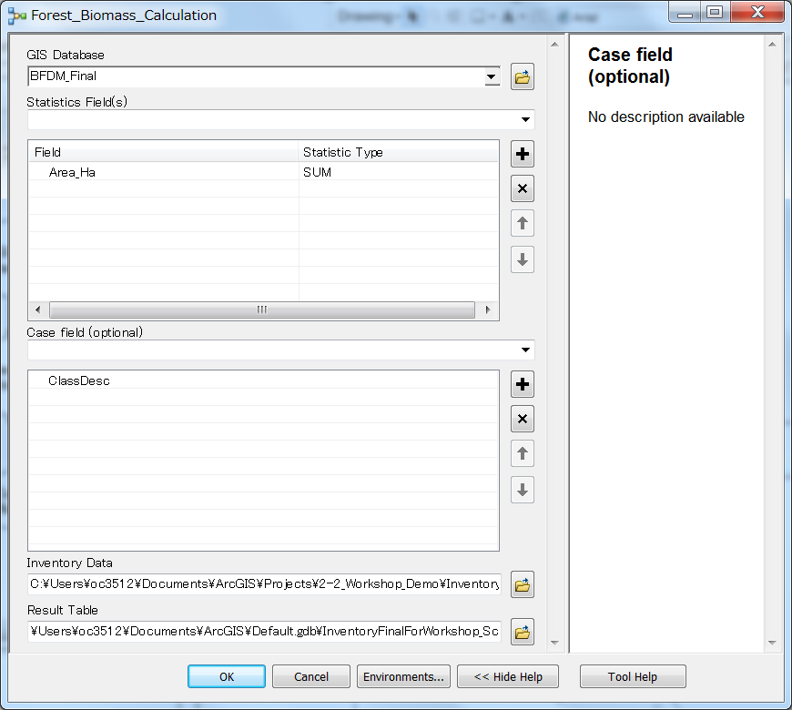

###### Run the model by clicking OK

* + Check if the model generated error.
  + In case of error, identify its source and review its potential.